PANEL PAINTING WEEKEND

AT CHÂTEAU THURIÈS
6-10 MAY 2021 & 7-11 oCTOBER 2021
COURSES LIMITED TO A MAXIMUM OF 4

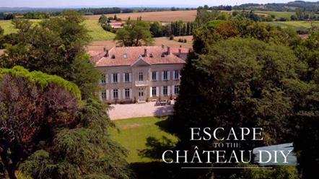
ESCAPE TO THE STUNNING FRENCH COUNTRYSIDE - Four nights – all inclusive, in super-king size suites.

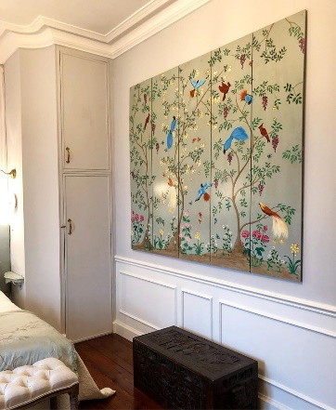

Would you like to create a decorative panel for your home like the chinoiserie or grisaille panels that Jayne painted on the programme ‘Escape to the Chateau DIY’?

Come along and, with guidance by Jayne, you will create a work of art on custom-sized panels to suit a wall or corner of your home, using a mixture of stencils and hand-drawing/painting.

Based in the studio at Château Thuriès, Jayne will be on hand to offer you as much (or as little!) guidance as you need to create an original piece of art to take home (panels can be posted at extra cost if it’s difficult to carry on the plane). Jayne will liaise with you prior to the course to find out the size that you would like the panel/s to be cut {or you can paint onto art paper if you would prefer} and also the subject matter to ensure that you have everything that you need.
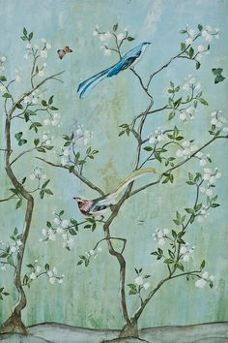
fULLY INCLUSIVE OF TUITION, FOOD & DRINK, AND ACCOMMODATION IN ONE OF THE CHATEAU’S LUXURY SUITES – COURSE NUMBERS LIMITED TO A MAXIMUM OF 5 AND ALL MATERIALS PROVIDED!

If your partner would like to come along but doesn’t want to participate in the painting, then they are very welcome to come along for just 250€. There are lots of things to do in the area or they can just chill with a glass of wine in hand!
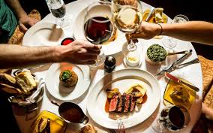
*Arrival Thursday/Departure Monday. (Flights into Toulouse Blagnac Airport or Carcassonne).
*All luxury suites have en-suite shower rooms, with super king-size beds - one twin room available.
*3 days painting, in the studio at the chateau.
*All meals are included, including breakfast, lunches and dinner at the Chateau. Wine, beer and soft drinks also included in the price
PROPOSED ITINERARY
Day 1 - Thursday
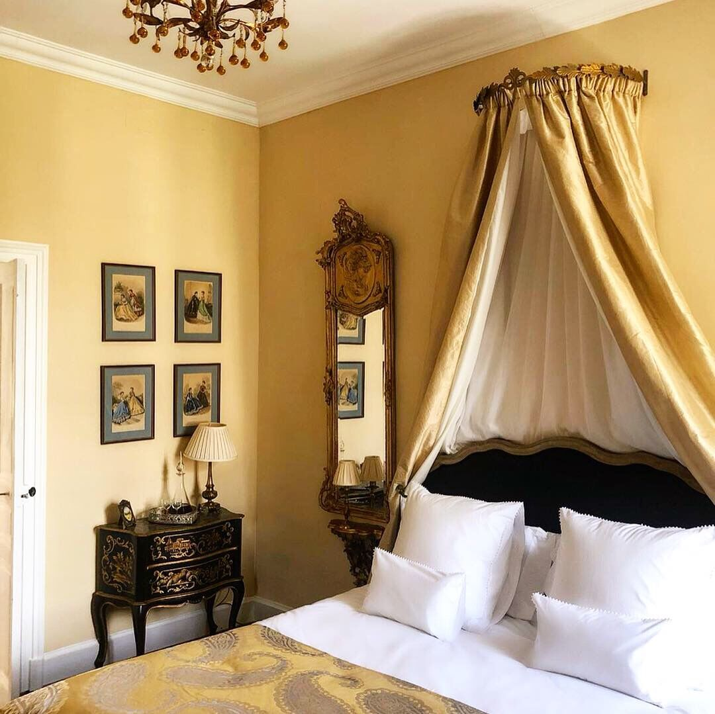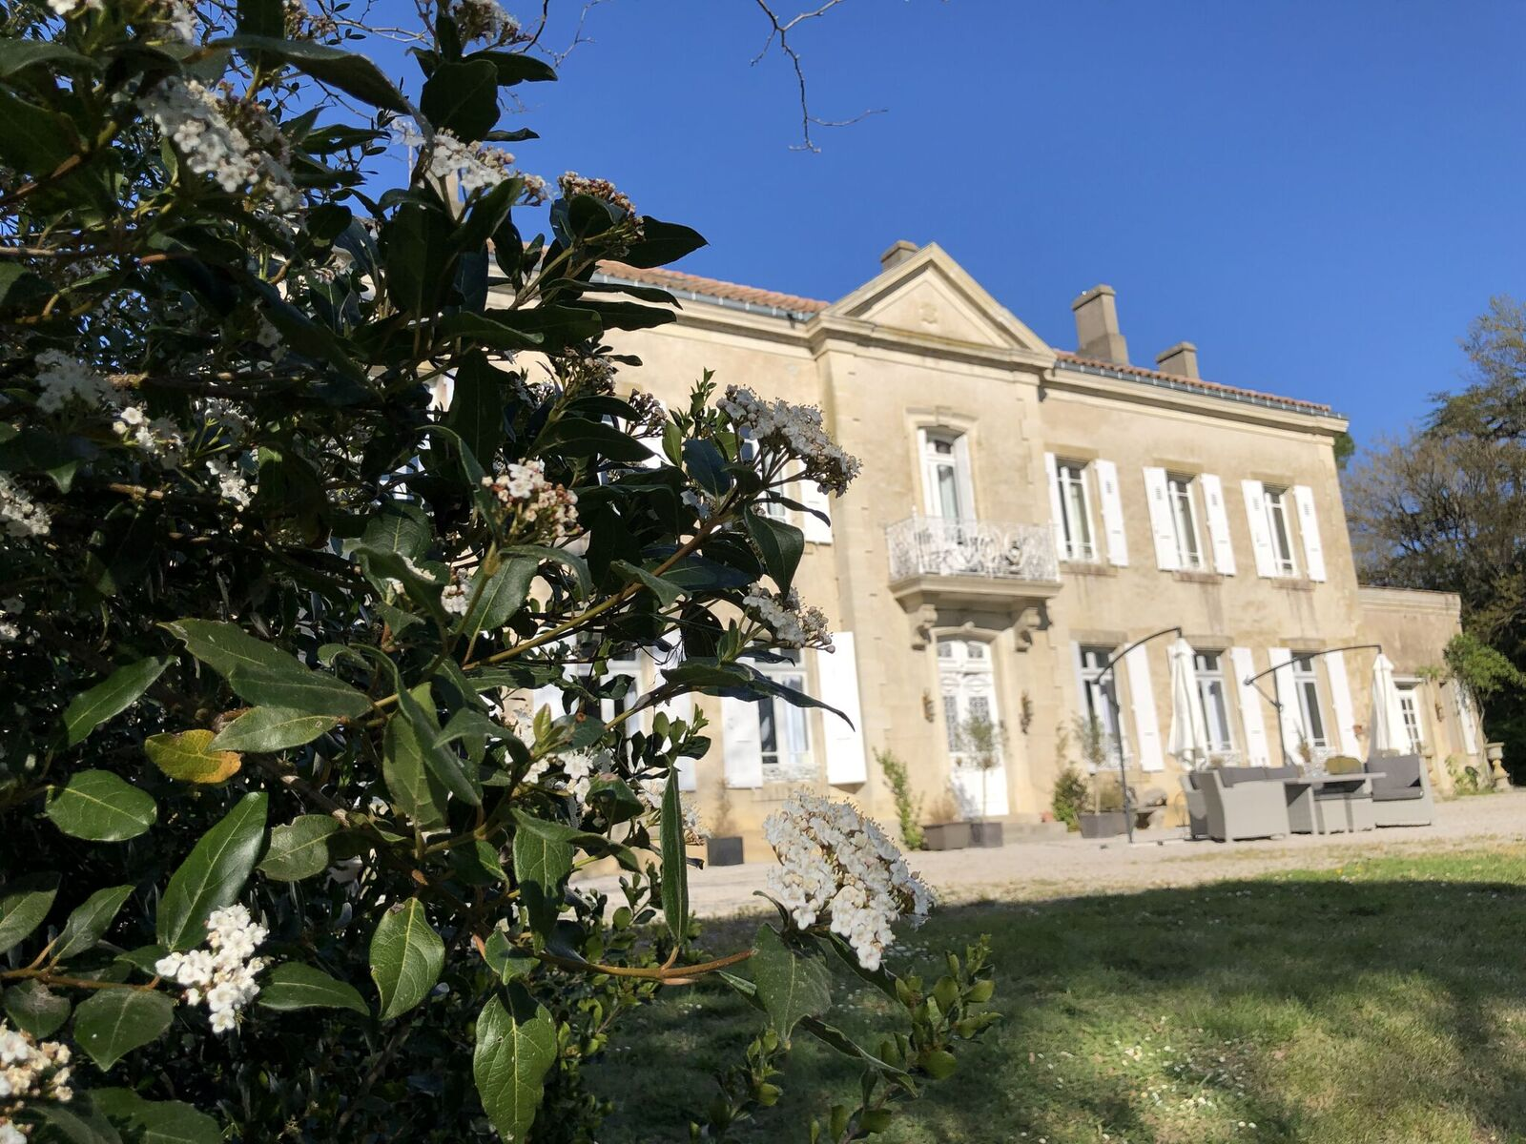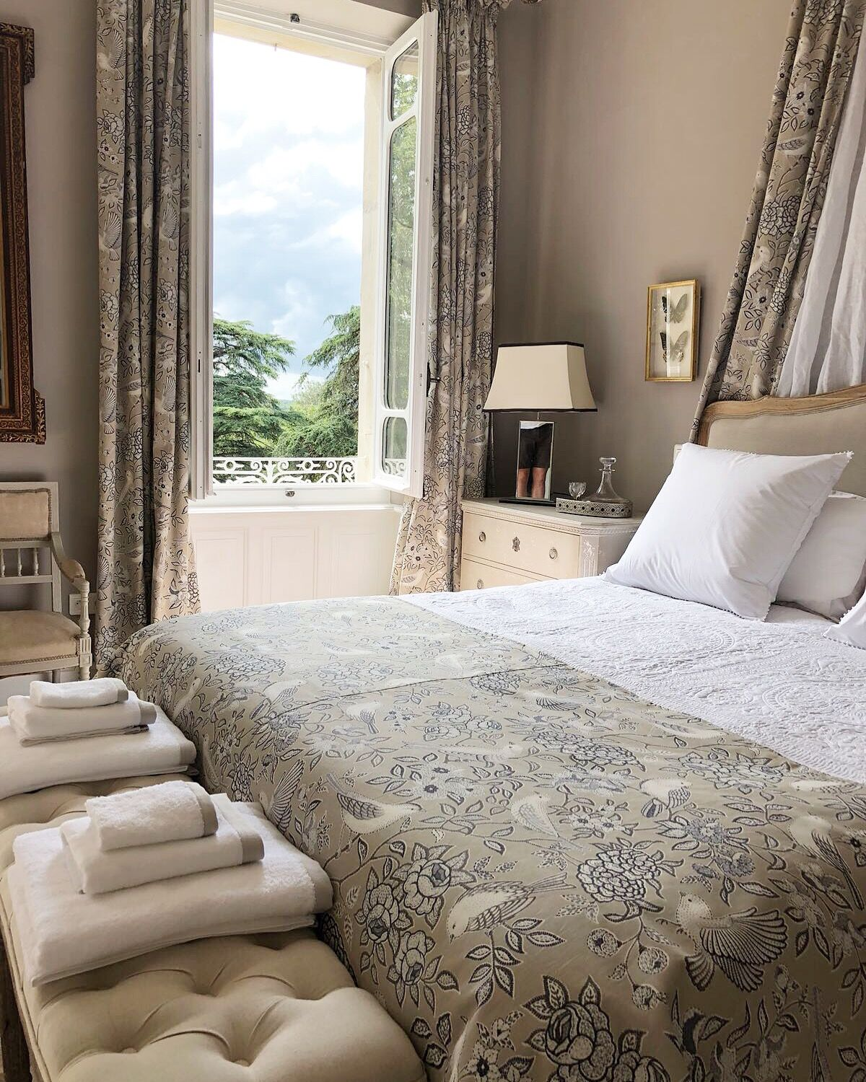

Arrival pm and welcome barbecue

Day 2 - Friday

Morning: Breakfast and studio based for initial planning and sketching for panels

Lunch at the Chateau

Afternoon: Continuation sketching and painting

Evening: Dinner at the Chateau
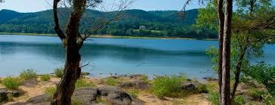
Day 3 - Saturday
Morning: Optional visit to the wonderful morning market in
Revel

Lunch: Back at the Chateau with goodies bought at the market
Afternoon: Continue with panels - painting and break before dinner.
Evening: Dinner at the Chateau

Day 4 - Sunday

Morning: Painting
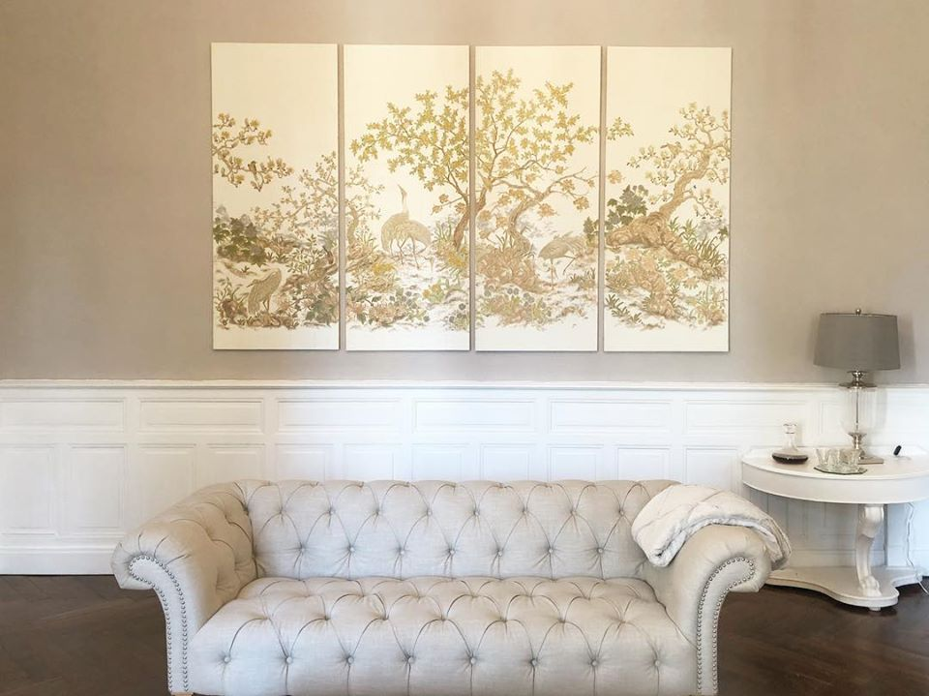

Lunch: Picnic at Lac St Ferreol (weather permitting)

Afternoon: Continuation of painting/sketching

Evening: Dinner at the Chateau

Day 5 - Monday

Morning: Breakfast and homeward bound! If you are

travelling late afternoon then you are also welcome to stay

for lunch and carry on with your painting/finishing off in

the studio.

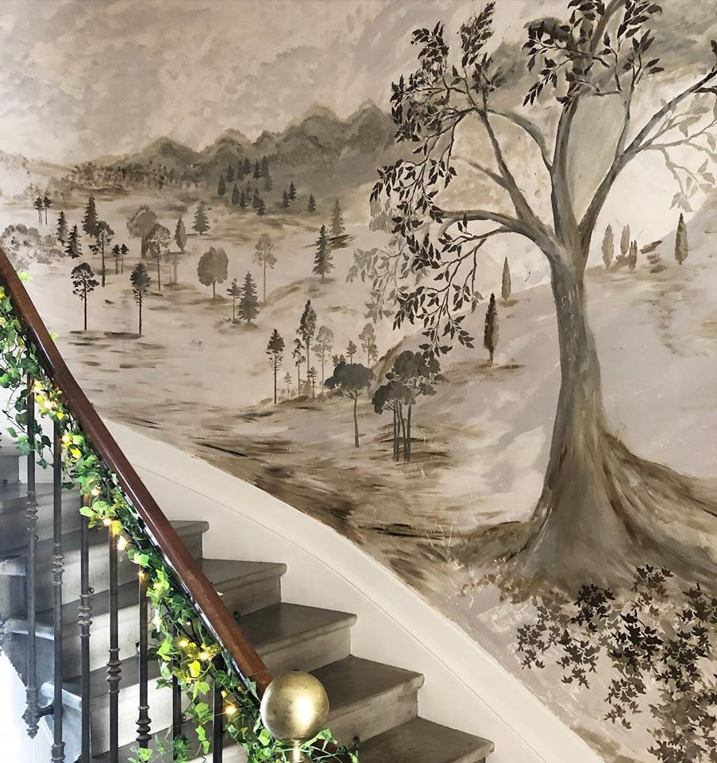

PRICING:

There are five luxury suites with en-suite bathrooms available. They will be allocated on a first-come, first-served basis (but if you have any special requests for a particular room we will be happy to help if it’s still available).
650 euros for a painter
350 euros for an additional painter, sharing (ie. 1000 euros for two painters)
250 euros for an additional non-painting guest, who is sharing a room (i.e 900 euros for one painter and a non-painter).

*These prices are inclusive of all accommodation, tuition and materials, food and drinks.

***Flights and transport from the airport are not included.

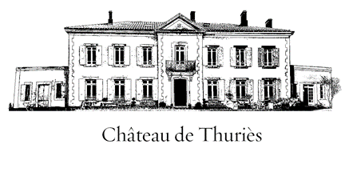
Details of all our bedroom suites and the chateau can be found at: www.chateauthuries.com
Contact: Jayne for more information and to book:
Tel: +44 (0)7736 255205 (English mobile)
email: bookings@chateauthuries.com

